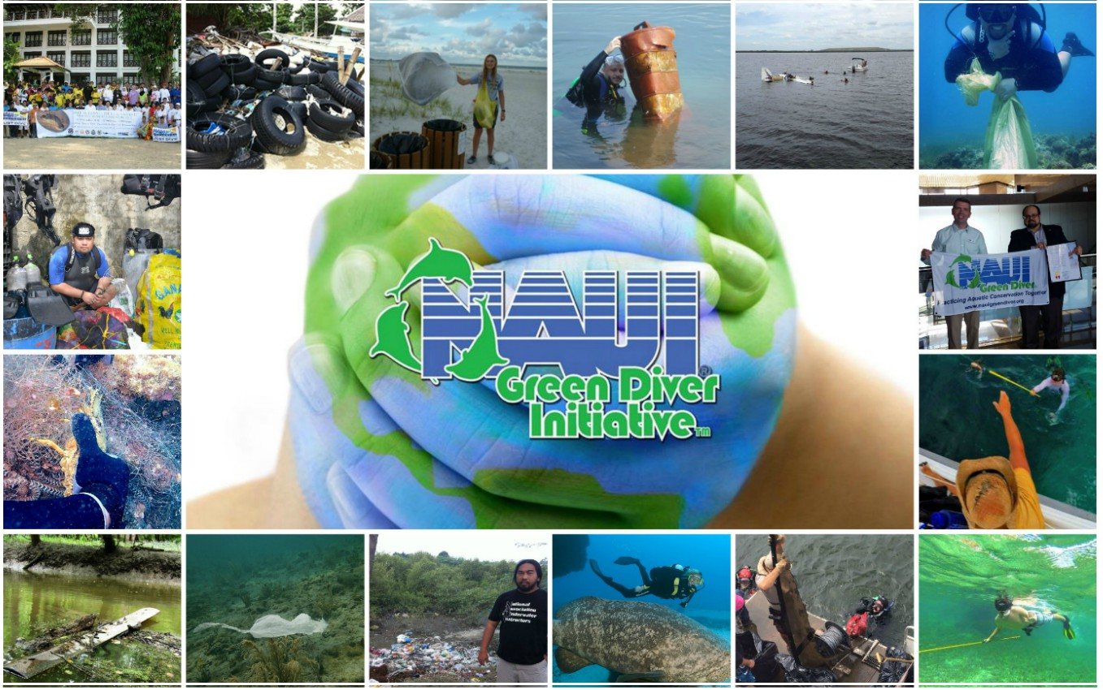

Dive4Change Grant Program
Guidelines

Why the need for the Dive4Change Grant Program?

Every day, divers around the world plunge into the open water to explore what lies beneath the waves – the thrill of discovery motivating and calling them to go deeper. With over 90% of the earth’s oceans having yet been explored by humans, divers are the explorers of the unknown.

Divers have a specific skill set that most of the world population does not possess – certification to safely go beneath the waves. With as many as six million active certified divers around the world, this specialized community has the power to actually tackle marine environment issues, hands-on.

Divers are making a positive impact on our waterways, diving not to just look at and enjoy nature, but diving with a purpose…

- Restoring coral reef communities
- Reducing the number of invasive fish, like lionfish, through targeted environmentally friendly methods
- Removing harmful marine debris from diving environments
- Tracking and surveying marine life communities, like sea turtles, manatees, sharks, and other threatened species
- Educating the public about environmental topics through ecotourism
- Documenting and promoting the aquatic world through photography and videography

The NAUI Green Diver Initiative strives to empower divers to continue to dive-in and explore, preserve and restore our waterways. Unfortunately, funding for individually inspired projects can be limited due to the fact that most granting agencies only allow non-profit organizations to apply. This leaves divers, eager to utilize their skills for the betterment of our environment, with few options for support.

GDI values the will and expertise divers bring to the world as citizen scientists. The Dive4Change Grant Program fills a void by providing the much needed support that individual divers are depending on to help them succeed – impacting real change for the future of our ocean planet.

Who is eligible to apply?

The NAUI Green Diver Initiative Dive4Change Grant Program is open to any individual 18 years or older, undergraduate and graduate level students in the field of marine science, and NAUI Worldwide members and affiliate partners. Proposals will be reviewed and awarded based on merit by committee.

At this time, to maximize the impact of the grant program, GDI will only grant up to $1,000 per proposal. Only one proposal can be submitted by the same individual(s) and partner organization(s) per year.

Past recipients must wait two years after last awarded grant before submitting a new proposal.
The program/project must have an impact on one or more of the following topics:

- Programs/projects related to the preservation and conservation of waterways (oceans, streams, lakes, estuaries, wetlands, etc.)
- Coral reef preservation or restoration
- The preservation and/or restoration of native plants
- Educational program/project focused on diving and environmental issues
- Marine life or habitat preservation and restoration programs/projects
- Water conservation and sustainability

If your program/project does not fit any of the above topics, please submit a one-page summary of the proposal. The committee will review and determine if it fits the mission of the grant program.

Grant recipients must provide the following:
- Detailed budget
- Properly completed grant proposal
- An update report, in the form of a short narrative (no more than two pages), must be submitted at least once during the project/program
- Final report, in the form of narrative. Must provide detailed results of the program/project, including relevant statistics and data
- At least one written article is required to be submitted summarizing the program/project so it can be disseminated by GDI and NAUI Worldwide

Grant Proposal Requirements

Proposal should be formatted as follows:

Double spaced in 12 pt. font, with one inch margins | Not exceed five pages | Have page numbers

The grant proposal must be divided into sections that answer the following questions:

1. What is the main issue, problem, or subject and why is it important?

The proposal should start with a discussion of the main issues, problems, or subjects that the applicant expects to address. It should go on to discuss why these are important and how they are related to the NAUI Green Diver mission.

2. Why is the applicant(s) qualified to address the issue or subject for which funds are being sought?

The applicant’s education, previous accomplishments, certifications, etc. related to the
proposed project should be discussed briefly.

3. What is the approach being taken?

The proposal should contain a summary of the overall approach to the subject, issue, or problem, and a detailed description of the proposed activities. The proposal should describe steps to be taken, by whom and when. If the proposal involves collaboration with other individuals or organizations, those collaborators and their expected contributions to the project should be listed. If applicable, the proposal should also describe the status of the work to date, and plans for dissemination and/or sustainability.

4. What will be the output from the project?

The proposal should include a discussion of anticipated products such as publications, programs, conferences, briefings, training of students, etc., that the project is expected to yield.

5. What is the amount of money requested?

The applicant should justify the budget request and why it is consistent with the associated output that the funds will support. This should be a general discussion, with additional detail provided in the budget section. (See “Budget”, below.)

6. What other sources of support does the applicant(s) have in hand or has applied for to support the project?

If funds are being provided or requested from other sources, the proposal should list those sources, amounts and the current status of funding from each. This narrative information can be integrated into the previous question, with detail provided in the budget section. (See “Budget, below.)

Confidentiality

The NAUI Green Diver Initiative requests that prospective grantees treat grant proposals as confidential during the application process and refrain from publicly distributing their proposals (in whole or part) and their status in the process until GDI has completed its evaluation and made a funding decision.

Dissemination

GDI believes that making program/project outputs freely an openly accessible can increase the reach and value of the grants awarded. We request:

- At least one written article should be written about the program/project so it can be disseminated by GDI and NAUI Worldwide
- GDI has the right to publish and promote the program/project for access by NAUI and GDI members
- Applicant must be available to be interviewed for the NAUI Dive Team podcast and other media

